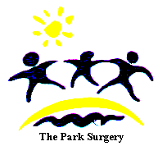

THE PARK SURGERY

AUTUMN NEWS 2023
Theparksurgerydriffield.nhs.uk

6 Eastgate North, Driffield, YO25 6EB
22a High St, Nafferton, Driffield YO25 4JR

REPEAT PRESCRIPTIONS – HELP US TO HELP YOU

Please note that we require AT LEAST 7 WORKING DAYS’ NOTICE for all repeat medication requests. If possible, please order your repeat prescription at the same time as you are collecting your current prescription. This will help to give us time to get your repeat prescription ready for when you require it. Thank you.

PATIENT PARTICIPATION GROUP



As patients your thoughts and opinion are very important to us, so we therefore would like to invite you to become a member of our Patient Participation Group. The idea is that this group supports the practice, giving vital feedback to the surgery, but is self-managed. Meetings are held approximately every 3 months. You need to be a registered patient and, if we do have lots of interest, we will select patients from different age groups. Please email theparkreception@nhs.net if you wish to be involved, we’d love to have you on board!

RUMOUR BUSTING- NAFFERTON SURGERY

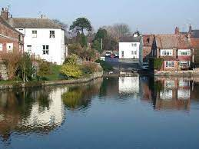

We have had many patients recently who have told us they have heard a rumour that we will be closing the Nafferton branch. We would like to re-assure all patients that there is no truth in this, we recognise that the Nafferton branch and its excellent staff provide a vital service for our patients who live in Nafferton and the surrounding areas. We have recently moved the dispensing of medicines to the Driffield surgery but patients can still collect their medicines from Nafferton should they wish the same way they always have.

PARKING AT THE PARK SURGERY

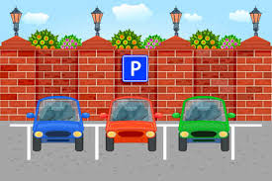
The surgery has had an issue with patients parking in disabled bays when they shouldn’t which has resulted in disabled patients having to park elsewhere, and sometimes off site. We realise our car park gets busy but that’s even more reason to make sure that disabled parking is available for those that really need it. Your co-operation is appreciated.

* * * * * * * * * * * * * * * *
FACEBOOK PAGE

Remember we have a Facebook page. Not all our patients are on Facebook but increasing numbers are and this will be an additional way of sharing information about how to best use your GP Surgery. Visit Park Surgery Driffield on Facebook and feel free to like us or leave feedback.
* * * * * * * * * * * * * * * *
TIME OUT FOR LEARNING

The practice will close for staff training on the afternoons (after 12:00) of 19th October 2023, 21st November 2023 and 14th March 2024. If you need a doctor urgently on these days, please ring 111 or ring the surgery where a message will direct you.

*******************************

WANT TO STOP SMOKING?

The Stoptober campaign is well under way to help you quit smoking.

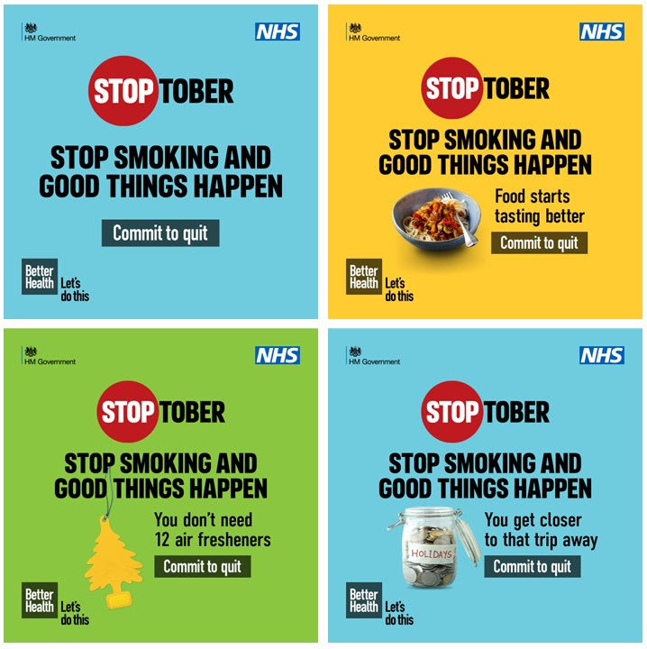

If you are interested in stopping smoking and want some help, you can contact the Better Health-quit smoking website at
www.nhs.uk/better-health/quit-smoking

* * * * * * * * * * * * *

TEXT MESSAGING

As you may know, we have increased the use of text messaging to our patients. We can now text a patient saving the wording of the text in the medical record and giving the patient the opportunity to respond if necessary. Also it gives us the ability to give the patient the option to send in photographs for the GPs and nurses to be able to review the condition in advance. We really hope that as many patient as possible join this service, which we hope you will find more convenient and less time consuming. You may have already given us consent to contact you in this way but if not, and you are happy to receive communication via text message, please let us know so we can ensure the consent information is accurate on your medical record.

*******************************

NHS APP

You may already be aware of this but for those of you with smart phones/tablets, you can download the NHS App free of charge which will give you access to online appointments and ordering of repeat medicines without you having to have any contact with the practice. You do need a passport or photo driving licence and an email address and it takes approximately 10 minutes to set up.

COLDS AND FLU

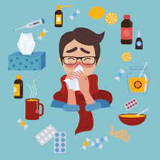

During autumn and winter months, upper respiratory infections are far more common. Mostly caused by viruses, these do not respond to antibiotics, so do not be surprised if your clinician does not prescribe one. Usually the body’s immune system will fight the virus but having an antibiotic does not kill the virus & can give unpleasant side effects, as well as increasing the likelihood of germs becoming resistant to antibiotics (such as C Difficile & MRSA).

It is usual for a cold and cough to last for at least 10 days, but if the cough persists for more than 3 weeks, then you should make an appointment to see your GP/nurse practitioner. Sore throats can last from 5-10 days and over 90% are caused by viruses. Ear pain that accompanies a sore throat or cold can last for 2-3 days but then resolve on its own.

With any of the above conditions, simple pain relief, such as paracetamol or ibuprofen (check with your pharmacist to ensure it is safe for you to take with any existing medications) will help to relieve symptoms, along with rest and plenty of fluids. However, if you have a high fever (above 39ºC) and are getting worse rather than better, or if it is a child under 2, or you are unduly concerned, then it is sensible to see a clinician or ring 111.

FLU AND CHILDREN

Any child over the age of 6 months who is in one of the above risk groups is eligible for an annual flu immunisation. Plus any child who is not in the risk group, but who is aged 2 – 3 may receive the vaccine. This is usually given in the form of a nasal spray unless there is a reason why they cannot receive this live vaccine, such as if the child is immunosuppressed, or has a severe wheeze. These children can have an injected, inactivated vaccine instead. School children who are in the eligible age range receive their vaccines at school. Children who are of pre-school age, or who are in the “at risk” categories can have the vaccine at the surgery.

NHS 111

The NHS 111 service will help you access urgent local health services when you need them and out of hours. Call NHS 111 if you need medical help fast, but it is not a 999 emergency.

About the Service

If you need to contact the NHS for urgent care there are only three numbers to know; 999 for life-threatening emergencies; The Park Surgery (during opening hours) 01377 272747; or 111.

When you call 111 you will be assessed, given advice and directed straightaway to the local service that can help you best – that could be an out-of-hours doctor, walk-in centre or urgent treatment centre, community nurse, emergency dentist or late opening chemist.

How the Service Works

- 111 will get you through to a team of fully trained call advisers, who are supported by experienced nurses. They will ask you questions to assess your symptoms and give you the healthcare advice you need or direct you to the right local service.

- The NHS 111 team will direct you to the people you need to speak to. If they think you need an ambulance, one will be sent just as quickly as if you had dialled 999.

When to Call

You should call NHS 111 if:

- you need medical help fast, but it is not a 999 emergency;

- you do not know who to call for medical help or you do not have a GP to call;

- you think you need to go to A&E or another NHS urgent care service; or

- you require health information or reassurance about what to do next.

Why People Should Use This Service

- When you need healthcare urgently NHS 111 will direct you straightaway to the local service that can help you best.

- NHS 111 can help us take the pressure off the 999 service and local A&E departments, so that they can focus on emergency cases.

